**RegNo: BP230503**

**NAME: S.Mohan**

**MSC Computer science**

**Removing duplication:**

**Program:**

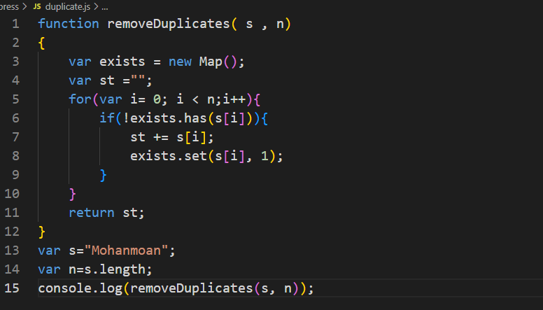

**Output:**

**moha.PNG**